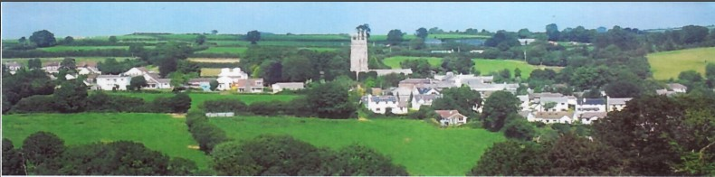

6rd May 2025

Dear Councillor,

You are summoned to attend a meeting of North Hill Parish Council on Thursday 15th May 2025 at 7.30pm in the Village Hall.

Please find attached the agenda for our meeting. We ask that if any member of the public has issues, they would like to raise that they contact the clerk prior to the meeting so that we can best manage them.

Please remember that the time allotted for Matters of Community Concern is not a forum to discuss what has taken place during this meeting and that any matter raised here would likely be added to the NEXT meeting agenda for discussion.

Yours faithfully,

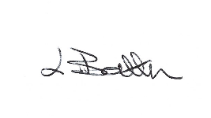

Lena Batten, Clerk to the Council

Members of the public are welcome to attend the meeting. However, we would like those attending to register prior to the meeting by emailing the Parish Clerk. Email: clerk@[northhillparish.org.uk](mailto:northhillparishcouncil@btinternet.com)

**AGENDA**

1. TO RECEIVE APOLOGIES:
2. CODE OF CONDUCT : a) TO RECEIVE DECLARATIONS b) TO GRANT DISPENSATIONS:

3. PUBLIC COMMENTS ON ITEMS ON THE AGENDA ONLY:

4. TO RECEIVE AND APPROVE THE MINUTES OF THE 7th APRIL 2025 FULL COUNCIL MEETING:

5. ANY MATTERS ARISING FROM PAST MINUTES NOT ON THE CURRENT AGENDA:

6. TO CONSIDER PLANNING APPLICATIONS RECEIVED FROM CORNWALL COUNCIL BY DATE OF THIS MEETING:

6.1 To note for information - PA24/08416 - Trebartha Barton, North Hill, Launceston, PL15 7PD - Proposal Construction of a new agricultural livestock building, creation of a new agricultural access and removal of an outdated livestock building - approved.

6.2 PA25/02742 – Penhallow, Chapel Lane, North Hill, PL15 7PQ – Demolition of existing wooden carport and replacement with single storey extension, construction of a single storey extension to the side and rear of the dwelling, installation of solar panels and other associated works without compliance of Condition 2 of Decision notice PA24/05278 – comments submitted to confirm North Hill Parish Council had no objections to the initial application but do not support an application which is not going to be carried out in accordance with the submitted plans.

6.3 To note for information – Land NW of Clampit House – planning enforcement have registered the complaint under reference number: EN25/00310 for further investigation.

6.4 To note for information – Hillside Lodge, Port Lane – planning enforcement have registered the complaint under reference number: EN25/00300 for further investigation.

7. ANY APPLICATIONS RECEIVED BEFORE THE DATE OF THIS MEETING: None.

8. TO REVIEW CORRESPONDENCE AND TO AGREED RESPONSES REQUIRED:

8.1 To confirm Zurich Insurance renewal quote at £407.50 to commence on the 1st June 2025, the last

year of a three year contract. Quotes will need to be sought in 2026.

8.2 To consider / accept the Draft Community Emergency Plan and any updates since last review.

8.3 To note for information receipt of the Grass Cutting agreement at St Torney’s Church for 2025-26 at

A total of £339.00 and the agreement for footpaths for 2025-26 at a total of £660.23.

8.4 To note for information the clerk has signed the contract on the 14th April 2025 for extended

warranty on the Elan City Speed Camera.

8.5 To agree / resolve the co-option of two members of the public present at the meeting.

8.6 To consider / resolve the two moderate risks identified by the recent ROSPA reports to include the

Steps and slide and the basket swing.

8.7 To note for information all Councillors are now booked on Code of Conduct training.

9. TO REVIEW DETAILS FOR NORTH HILL PARISH COUNCIL CEMETERY:

To agree / resolve a date for the next meeting for North Hill Parish Cemetery working group and discuss / consider option of using CIL funds for works to cemetery.

10. APPROVAL OF THE LIST OF PAYMENTS / RECEIPTS FOR APRIL 2025 & TO RECEIVE 28th APRIL 2025 BANK STATEMENT:

10.1 AUTHORISATION OF EXPENSES INCLUDING SALARY:

i) £18.00 (PAYE G. Pollard payroll April, dd)

ii) £759.20 (Lena Batten, April Salary / tax)

iii) £43.64 (room rent)

iv) £96.00 (Internal Annual Audit, G. Pollard)

v) £149.17 (Elan city, extended warranty)

vi) £407.50 (Zurich insurance)

vii) £45.00 (North Hill Village Hall room hire)

viii) £105.00 (ICCM annual subscription)

ix) £414.00 (TDP Dale bench)

x) £201.60 (ROSPA annual play area checks)

10.2 RECEIPTS:

i) £1.13 (transfer from savings account)

ii) £133.17 (VAT reimbursement)

iii) £8,800 (Precept 1st instalment)

iv) £195.56 (CIL Payment)

10..3 To receive bank statement:

Bank Statement as of 28th April 2025 £20,172.91.

10.4 To receive / approve the finding of the internal audit report and Annual Governance Statement.

10.5 To receive / set the commencement date for the exercise of public rights.

10.6 To receive / approve the accounting statements.

10.7 To confirm £1.13 has been removed from the savings account into current account at HSBC.

11. TO REVIEW MONTHLY BUDGET RECONCILIATIONS:

11.1 Budget Sheet Attached.

12. TO REVIEW MONTHLY RAG: (Red, Amber, Green)

12.1 RAG Sheet attached.

13. REPORT FROM CORNWALL COUNCIL WARD MEMBER COUNCILLOR PARSONS:

14. ITEMS FOR INCLUSION AT THE NEXT MEETING:

15. DATE & TIME OF NEXT MEETING:

16. CLOSE OF BUSINESS: